Project Report

Group : 12

HTML based Web Development



Acknowledgement

We would like to extend our heartfelt thanks and appreciation to all those who contributed to the successful completion of this HTML based web development project.

First and foremost, we want to acknowledge the hard work and dedication of each member of our team who worked tirelessly to ensure that this project was completed on time and to a high standard. Without their commitment and effort, this project would not have been possible.

We would also like to express our gratitude to our guide **Miss. Vindya senanayake** for her guidance and support throughout the project. her feedback and advice were invaluable in helping us to refine our ideas and to develop a cohesive and effective strategy.

Finally, we want to thank all the stakeholders who provided us with their valuable feedback and inputs during the development process. Your contributions were instrumental in shaping the direction of the project and ensuring that it met the needs of its intended audience.

Thank you all once again for your contributions to this project. We are proud of what we have achieved together and look forward to future collaborations.

**CONTENT**

1. Introduction…………………………………………….

Project Definition

Objectives

Tool used

1. Design of the webpage………………………………...
2. Implementation…………………………………………

1. Initial plan …………………………………………….
2. Work contribution table………………………………...
3. Future enhancements…………………………………...
4. Bibliography……………………………………………
5. Details of group members……………………………...

**Introduction**

* **About "GREEN HANDS"**

A community-based effort called GreenHands uses tree-planting campaigns to advance sustainability and environmental protection. The project aims to increase public understanding of the value of trees in preserving ecological harmony and reducing the effects of climate change.

GreenHands works to improve the quantity of green areas in neighborhoods, the quality of the air and water, and wildlife habitats by planting trees. Along with developing a sense of community and social responsibility, the project also seeks to engage and empower volunteers to take action in support of environmental sustainability. In addition to planting trees, GreenHands offers training and education programs to assist local residents in their sustainability efforts.

The project also collaborates closely with educational institutions to incorporate environmental education into the curriculum and raise students' knowledge of environmental issues.

* **Objectives**
  + - Provide information and resources on sustainable living.
    - Raise awareness about the importance of environmental protection.
    - To engage people in environmental activities.
    - Work towards a more sustainable future.
    - Promote sustainability and protect the environment.
    - To build a community of individuals and organizations that share a common interest in sustainability and work together to achieve goals.
* **Tools used in the design & development of the website**
  + **Design tools : Canva**
  + **Web browser : Google Chrome 110.0.5481.104 (Official Build)(64-Bit)**
  + **Front-end Development : HTML5, CSS3**
  + **Code editor : Visual Studio Code**
  + **File management : Nautilus**
  + **Code Host : Github**

**Design**

* **Home Page**

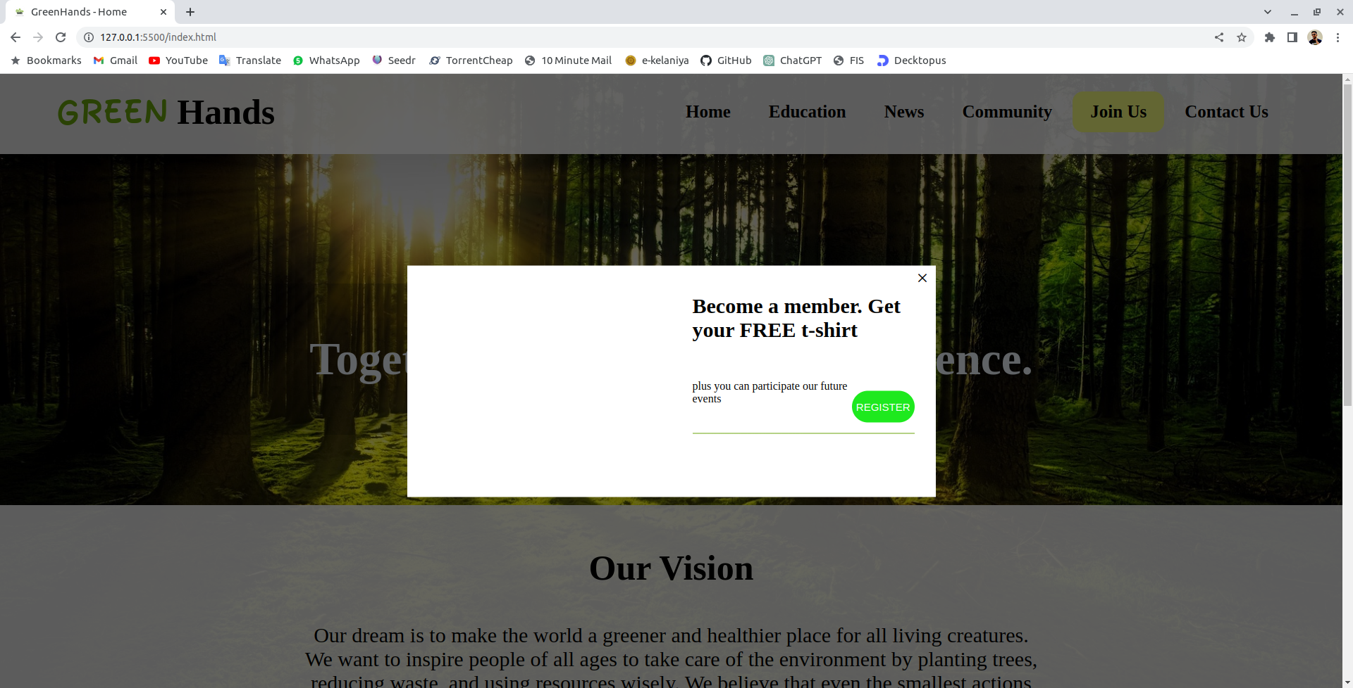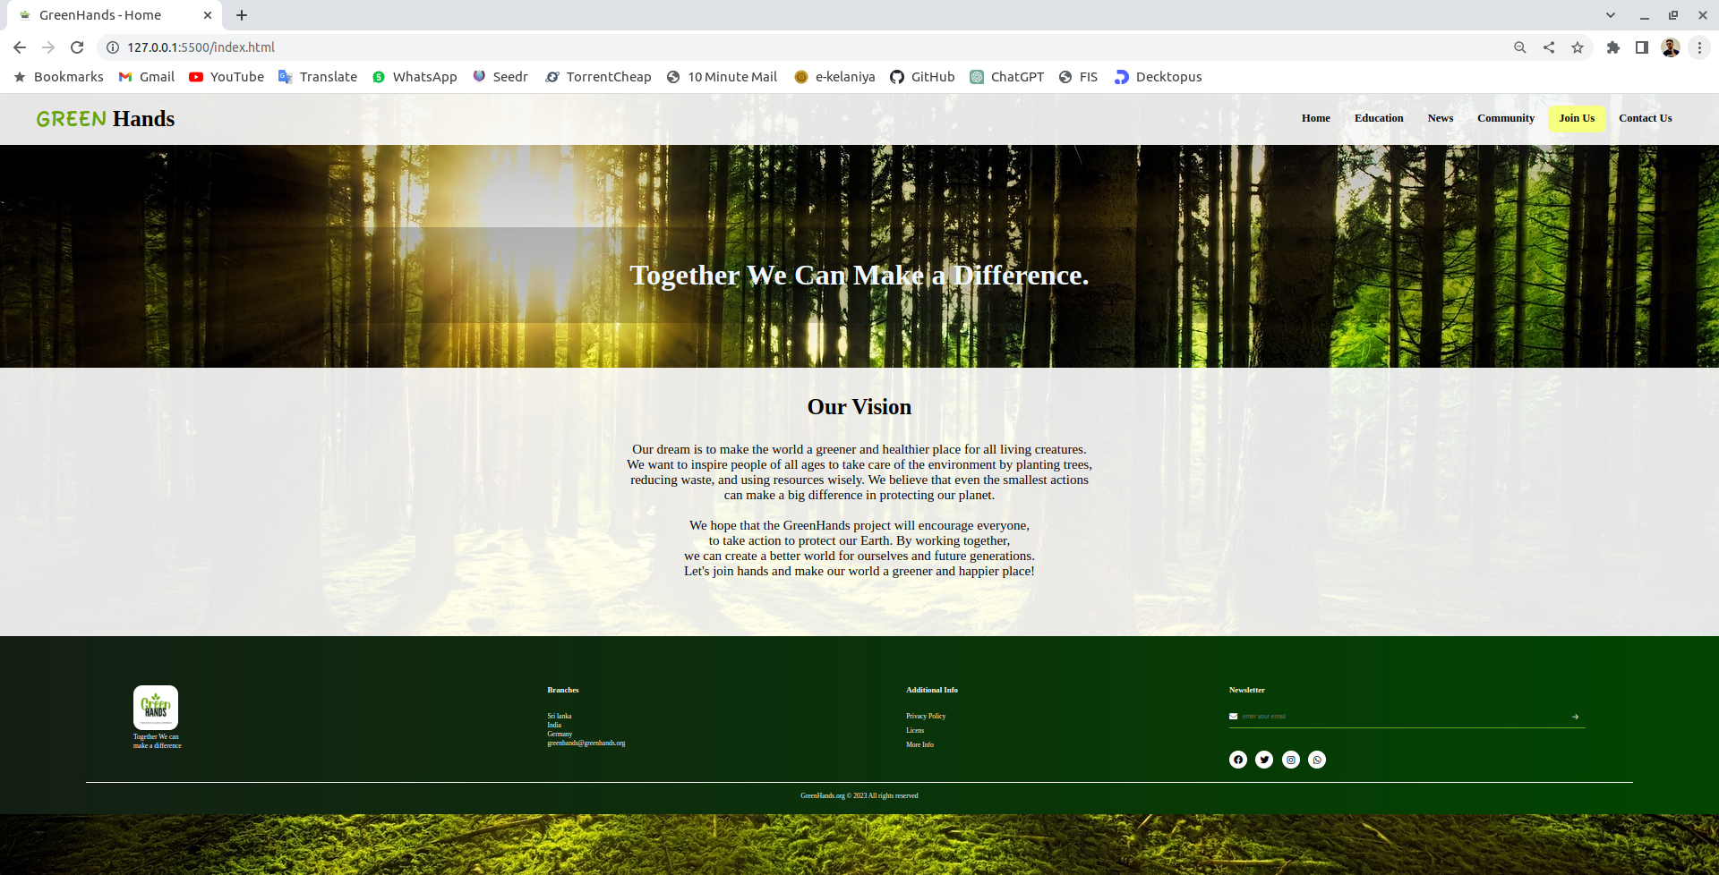

* **Education Page**

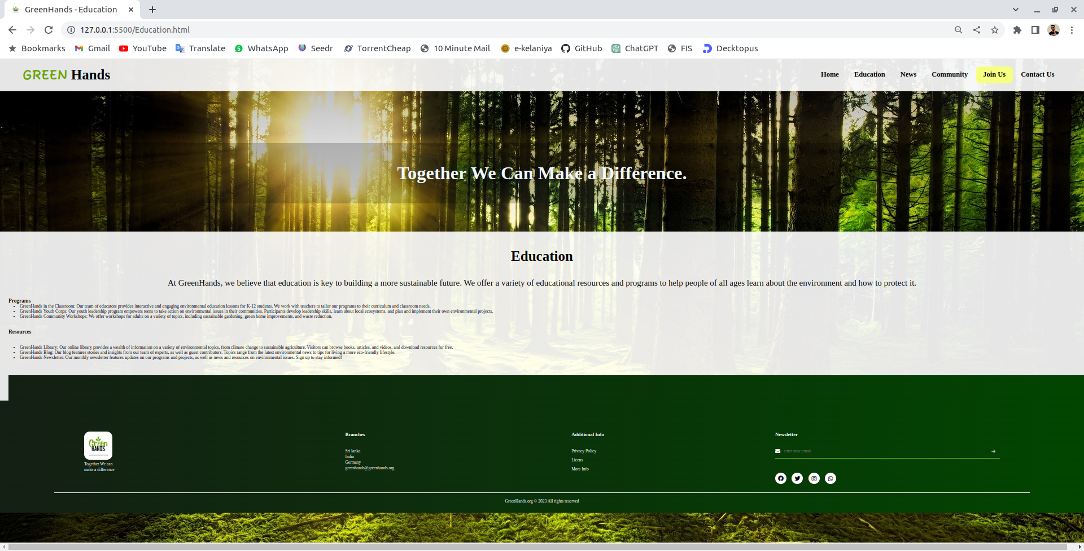

* **News Page**

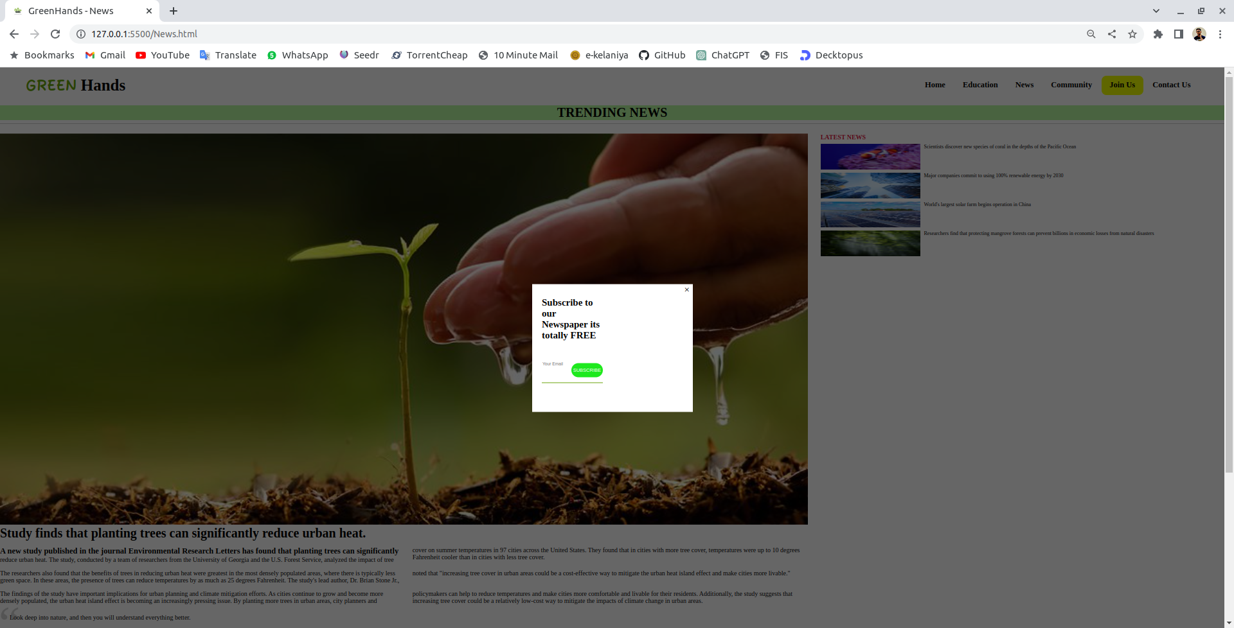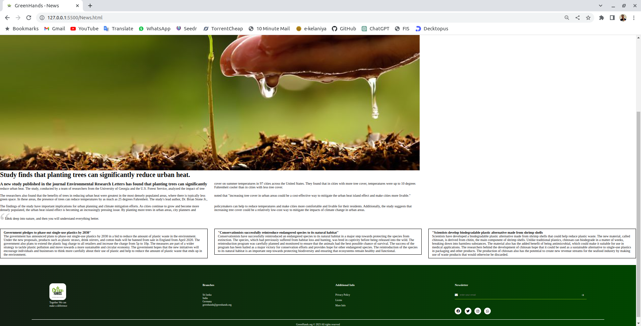

* **Community Page**

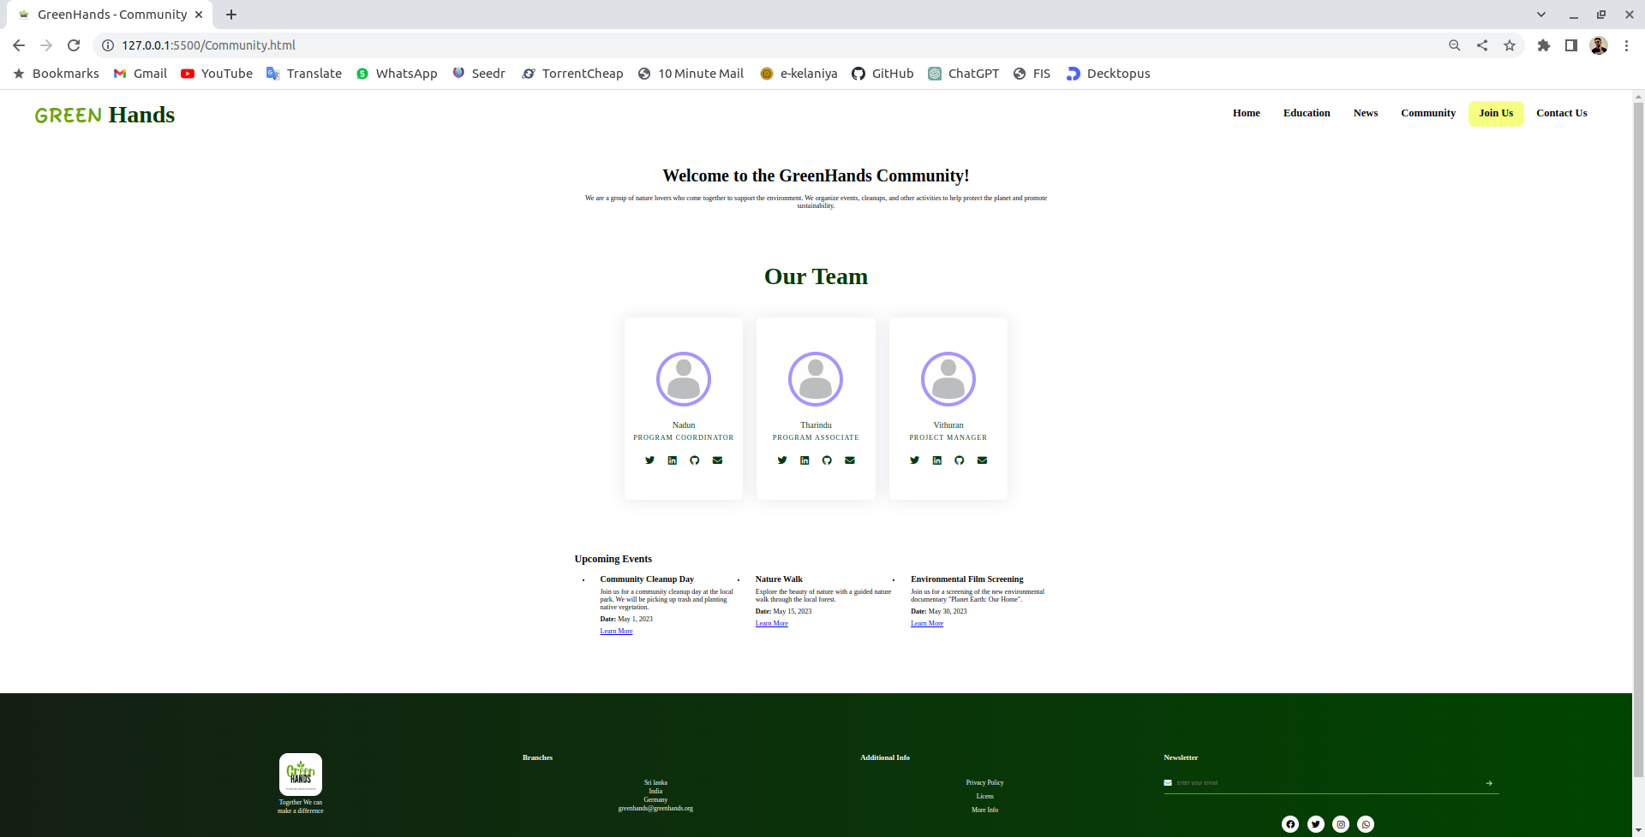

* **Join Us Page**

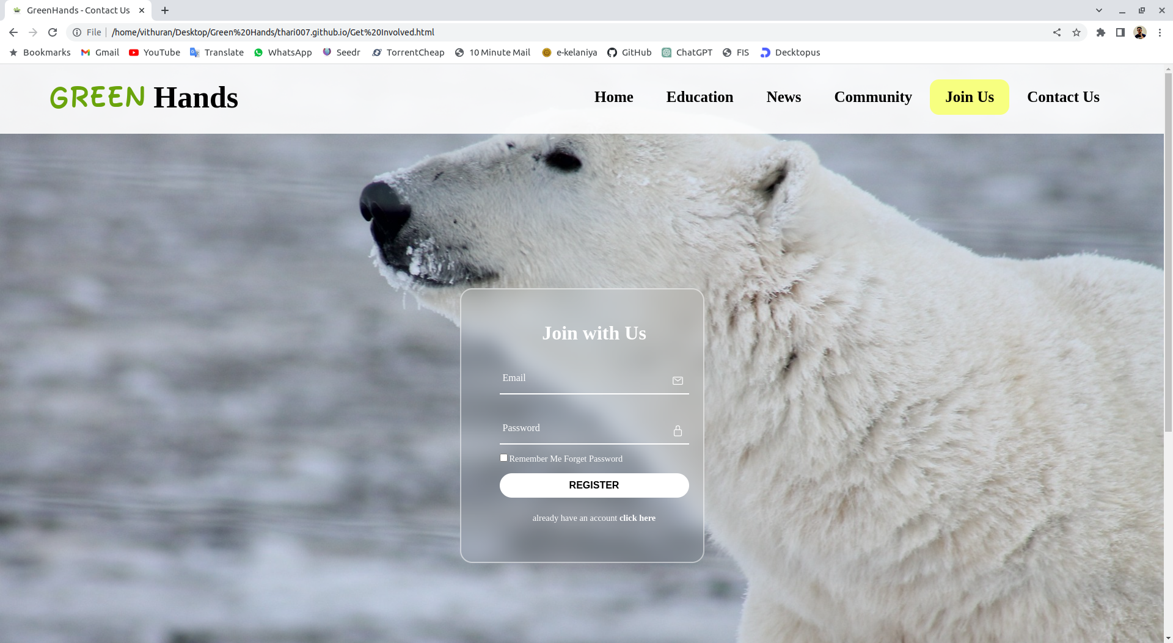

* **Contact Us Page**

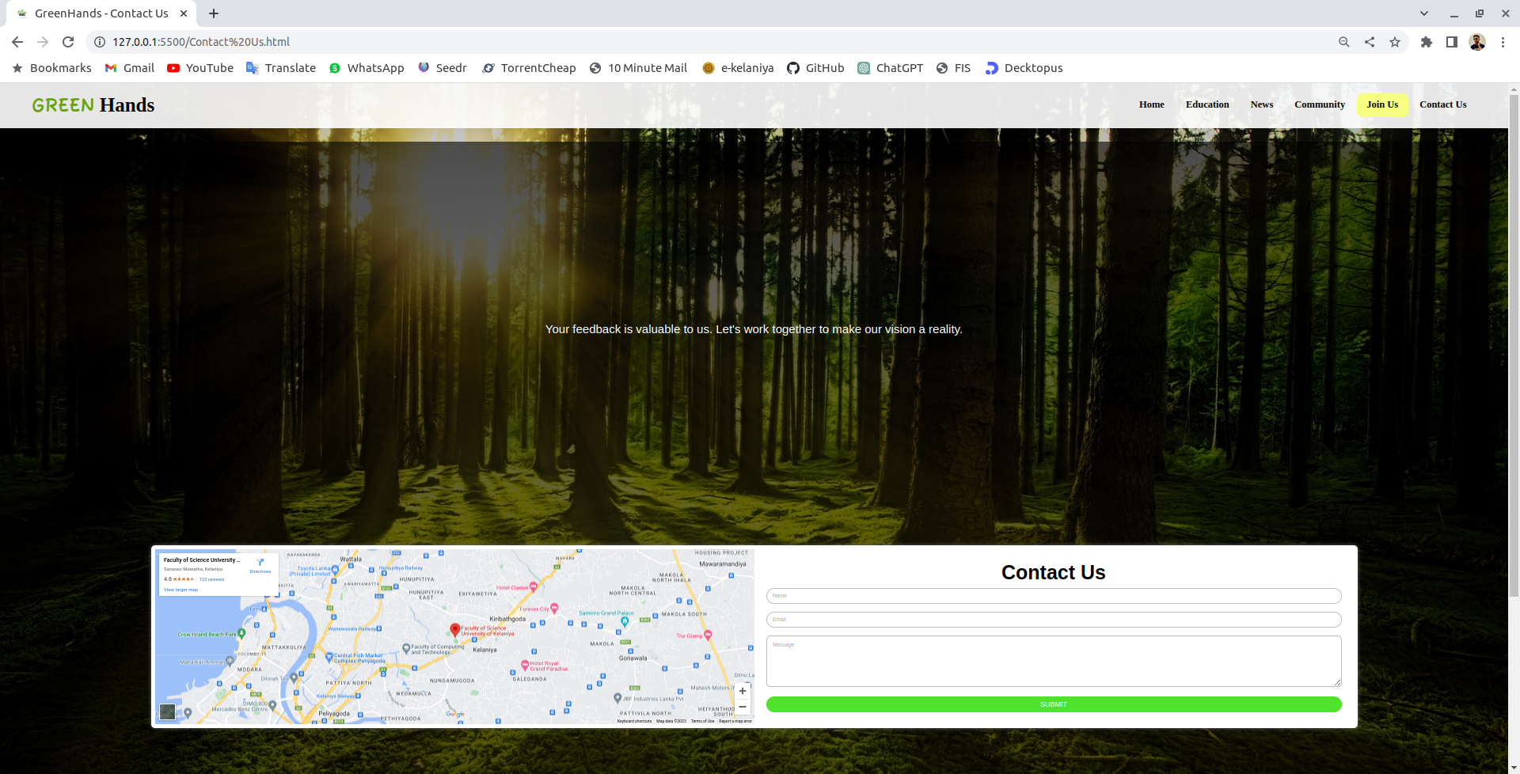

**Implementation**

* **Website link :** https://thari007.github.io/
* **Home Page**

<!DOCTYPE html>

<html>

<head>

<meta charset='utf-8'>

<meta http-equiv='X-UA-Compatible' content='IE=edge'>

<title>GreenHands- Home </title>

<meta name='viewport' content='width=device-width, initial-scale=1'>

<link rel='stylesheet' type='text/css' media='screen' href='css/homestyle.css'>

<link href="https://fonts.googleapis.com/css2?family=Fuzzy+Bubbles:wght@700&display=swap" rel="stylesheet">

<script src="https://kit.fontawesome.com/26068994f4.js" crossorigin="anonymous"></script>

<style>

</style>

</head>

<body>

<header>

<div class="logo">

<h1><span class="green" >GREEN</span> Hands</h1>

</div>

<nav class="nav1">

<ul>

<li> <a href="index.html">Home</a></li>

<li><a href="Education.html">Education</a></li>

<li><a href="News.html">News</a></li>

<li> <a href="Community.html">Community</a></li>

<li style="background-color: #f7ff80; border-radius: 15px; border-color: black; "><a href="Get Involved.html">Join Us</a></li>

<li> <a href="Contact Us.html">Contact Us</a></li>

</ul>

</nav>

<nav class="nav2">

<ul>

<li> <a href="index.html">Home</a></li>

<li><a href="Education.html">Education</a></li>

<li><a href="News.html">News</a></li>

<li> <a href="Community.html">Community</a></li>

<li><a href="Get Involved.html">Join Us</a></li>

<li><a href="Contact Us.html">Contact Us</a></li>

</ul>

</nav>

</header>

<div class="greeting" style="text-align: center; ">

<h2 style="font-size: 65px; color: aliceblue;">Together We Can Make a Difference.</h2>

</div>

<div class="vision">

<h2 style>Our Vision</h2>

<p>

Our dream is to make the world a greener and healthier place for all living creatures. <br>

We want to inspire people of all ages to take care of the environment by planting trees, <br>

reducing waste, and using resources wisely. We believe that even the smallest actions <br>

can make a big difference in protecting our planet. <br>

<br>

We hope that the GreenHands project will encourage everyone, <br> to take action to protect our Earth. By working together, <br>

we can create a better world for ourselves and future generations. <br>

Let's join hands and make our world a greener and happier place!

<br>

</p>

</div>

</div>

<div class="donation">

</div>

<footer>

<div class="row">

<div class="col">

<img class="footerlogo" src="images/logo.png" alt="">

<p class="motto">Together We can <br>

make a difference<br>

</p>

</div>

<div class="col">

<h3>Branches</h3>

<p>Sri lanka</p>

<p>India</p>

<p>Germany</p>

<p class="email-id">greenhands@greenhands.org</p>

</div>

<div class="col">

<h3 style="left:40px;">Additional Info</h3>

<ul class="footlist">

<li class="fl"><a href="">Privacy Policy</a> </li>

<li class="fl"><a href="">Licens</a> </li>

<li class="fl"><a href="">More Info</a> </li>

</ul>

</div>

<div class="col">

<h3>Newsletter</h3>

<form action="">

<i class="fa-solid fa-envelope"></i>

<input type="text" placeholder="enter your email" required>

<button type="submit"><i class="fa-solid fa-arrow-right"></i></button>

</form>

<div class="socialmedia">

<i class="fa-brands fa-facebook"></i>

<i class="fa-brands fa-twitter"></i>

<i class="fa-brands fa-instagram"></i>

<i class="fa-brands fa-whatsapp"></i>

</div>

</div>

</div>

<hr>

<div class="copyright">

GreenHands.org © 2023 All rights reserved

</div>

</footer>

<div class="popup">

<div class="login-popup">

<div class="box">

<div class="img-area">

<div class="img">

</div>

<h1></h1>

</div>

<div class="form">

<div class="close">&times;</div>

<h1>Become a member. Get your FREE t-shirt </h1>

<form>

plus you can participate our future events

<a href="Get Involved.html"><button type="button" class="btn">Register</button></a>

</form>

</div>

</div>

</div>

</div>

<script src="script.js"></script>

</body>

</html>

**Initial plan of the webpage**

* **Home Page**
  + - * Brief introduction of the website's purpose and goals
      * Navigation menu to other pages on the website
      * Featured content (e.g. articles, products, etc.)
* **Education Page**
  + - * Live or recorded webinars related to sustainable gardening and agriculture, featuring guest speakers and experts
      * Personal stories and experiences related to sustainable gardening and agriculture education
      * Webinar descriptions, schedules, and registration information
      * A collection of articles on topics related to sustainable gardening and agriculture, such as composting, organic gardening, and water conservation
* **News Page**
  + - A collection of the latest news stories related to sustainability, gardening, and agriculture
* Categories and tags to help users find specific news stories
  + - Short, informative articles offering practical tips for living a more sustainable lifestyle
    - Archive of past newsletters sent out by the website, featuring news stories, editorials, features, and green tips
* **Community Page**
  + - A listing of local volunteer opportunities related to sustainability, gardening, and agriculture
    - An online forum where users can discuss sustainability, gardening, and agriculture topics
* Categories and tags to help users find specific discussions
  + - A calendar of local and online events related to sustainability, gardening, and agriculture
* Event descriptions, dates, times, and registration information
* **Join Us Page**
  + - A list of the benefits of becoming a member, such as access to exclusive content, discounts on products and courses, and participation in member-only events
* Membership levels and pricing information
  + - A call-to-action to encourage users to become members
    - Registration form with fields for personal information and payment details
* **Contact Us Page**
  + - A contact form for users to send a message to the website
* Fields for name, email, subject, and message
  + - An email address for users to send messages directly to the website
* Instructions for including necessary information in the message
  + - A phone number for users to call the website with questions or feedback
* Business hours and availability information

**Work contribution table**

|  |  |  |  |
| --- | --- | --- | --- |
| **Name** | **Tasks Assigned** | **Task Completed** | **Progress (%)** |
| Nadun | Design & Layout  Homepage, About Us page, Footer | Information Gathering, Design & layout of the web pages | 100% |
| Tharindu | Design & Layout  Get involved page, Education page, News Page | Information Gathering, Design & Layout of the web pages | 100% |
| Vithuran | Design & Layout  Community page, Contact us page | Information Gathering, Design & Layput of the web pages | 100% |

**Future enhancements**

* Interactive Tools: Create interactive tools such as a carbon footprint calculator, a water usage tracker, or a plant identification tool to engage users and provide them with practical information related to sustainability and gardening.
* E-Commerce: Create an e-commerce section where users can purchase sustainable gardening and agriculture products, such as seeds, compost, or gardening tools. This would not only provide a source of revenue for the website, but also make it easier for users to find and purchase sustainable products.
* User-generated Content: Allow users to submit their own content, such as blog posts, success stories, or photos, to be featured on the website. This would encourage user engagement and create a sense of community around sustainability and gardening.
* Online Courses: Offer online courses related to sustainability and gardening, such as composting, organic gardening, or permaculture design. These courses could be offered for a fee and provide users with a more comprehensive and structured learning experience.
* Local Resources: Create a database of local resources, such as community gardens, farmers markets, or sustainable agriculture organizations, to help users connect with sustainable initiatives and communities in their area.
* Gamification: Create a gamified experience that encourages users to engage in sustainable practices and gardening activities. For example, users could earn points or badges for completing sustainable tasks or participating in gardening challenges.
* Mobile App: Develop a mobile app that allows users to access the website's content and features on-the-go. The app could also provide location-based information on local resources and sustainable initiatives.

**Bibliography**

* COST 22073 Lecture Notes
* WWW.W3Schools.com
* WWW.tutorialspoint.com
* WWW.Google.com
* WWW.Youtube.com

**Group Members**

A.T.N Athukorala

(Group Leader)

PE_2019_043

[athukor-pe19043@stu.kln.ac.lk](mailto:athukor-pe19043@stu.kln.ac.lk)

K.Vithuran

PE_2019_048

[Vithura-pe19048@stu.kln.ac.lk](mailto:Vithura-pe19048@stu.kln.ac.lk)

Nadun Thennakoon

PE_2019_060

[Thennak-pe19060@stu.kln.ac.lk](mailto:Thennak-pe19060@stu.kln.ac.lk)

21